Implications of committing to

Market Segmentation

Market segmentation can be a key marketing strategy, but it requires a long-term commitment and substantial investments in research, product development, pricing, distribution channels, and communication. To maximize the benefits of market segmentation, organizations need to organize around market segments, rather than products. The decision to pursue a market segmentation strategy should be made at the highest execution level and systematically communicated and reinforced across all organizational levels and units.

Implementation Barriers

Several barriers to the successful implementation of a market segmentation strategy in organizations are identified in various books, including lack of leadership and resources from senior management, resistance to change and lack of market orientation in the organizational culture, lack of training and expertise, objective restrictions, process-related barriers, and difficulty in understanding and interrupting results. These barriers can be proactively removed, but if not, abandoning the attempt should be considered. To succeed, dedication, patience, and a willingness to appreciate the challenges are required.

Specifying the Ideal Target Segment

Segment Evaluation Criteria

The third layer of market segmentation analysis relies heavily on user input throughout the process rather than just at the beginning or end. The organization must determine two sets of criteria for segment evaluation: knock-out criteria (essential, non-negotiable features) and attractiveness criteria (used to evaluate the relative attractiveness of remaining segments). The literature proposes a wide array of possible criteria, but the segmentation team must select which ones to use and assess their relative importance. Knock-out criteria automatically eliminate some segments, while attractiveness criteria are negotiated and then applied to determine the overall relative attractiveness of each market segment.

Knock-Out Criteria

Knock-out criteria are used to determine if market segments qualify for assessment using segment attractiveness criteria. The criteria include homogeneity, distinctiveness, size, matching strengths of the organization, identifiability, and reachability. These criteria are non-negotiable and must be understood by senior management, the segmentation team, and the advisory committee. The exact minimum viable target segment size needs to be specified.

Implementing a Structured Process

The article discusses the importance of a structured approach to evaluating market segments and recommends the use of a segment evaluation plot to assess segment attractiveness and organizational competitiveness. It suggests that a team of people should determine the criteria for both these factors, and representatives from various organizational units should be included in the process. The article emphasizes the importance of selecting attractiveness criteria at an early stage in the process to facilitate data collection and make target segment selection easier. It also recommends allocating weights to each criterion based on their relative importance, through negotiation and agreement among team members and approval from the advisory committee.

Collecting Data

Segmentation Variables

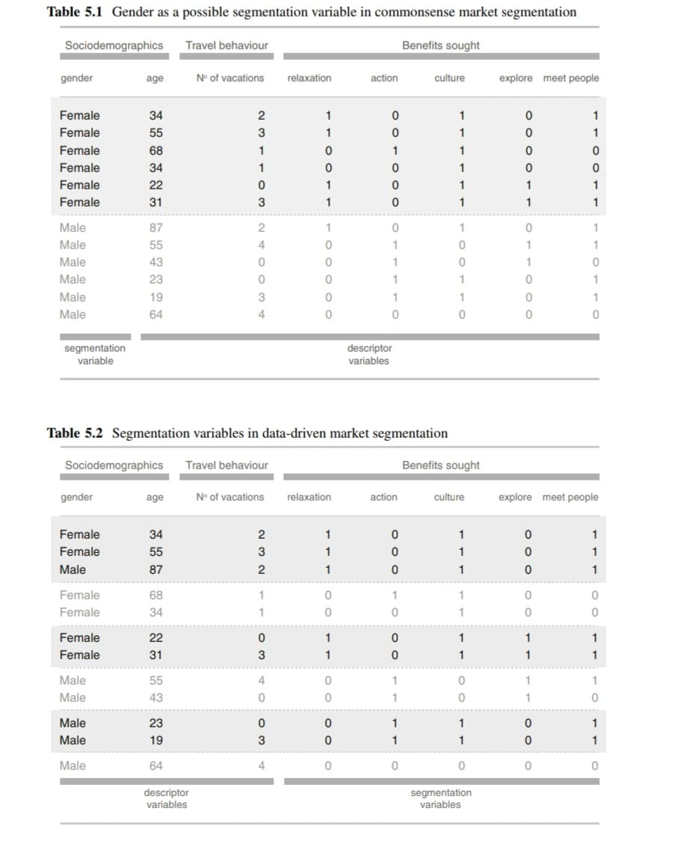

The article discusses the importance of empirical data in market segmentation, which forms the basis of both commonsense and data-driven approaches. In commonsense segmentation, a single characteristic is used as the segmentation variable to split the sample into market segments. In contrast, data-driven segmentation involves multiple segmentation variables to identify naturally existing or artificially created market segments. Good empirical data is critical for developing a valid segmentation solution, and it can come from a range of sources, such as survey studies, observations, and experimental studies. The source that delivers data most closely reflecting actual consumer behavior is preferable. The quality of empirical data determines the quality of the extracted market segments and the quality of the descriptions of the resulting segments, which is critical for developing a customised product, pricing strategy, distribution channel, and communication channel for advertising and promotion.

Segmentation Variables

Before data for market segmentation is collected, an organization must decide which segmentation criterion to use. The most common criteria are geographic, socio-demographic, psychographic, and behavioral. There are many different segmentation criteria available, but the recommendation is to use the simplest possible approach that works for the product or service at the least possible cost. The decision cannot be outsourced and requires prior knowledge about the market. The relevant differences between consumers for market segmentation are profitability, bargaining power, preferences, barriers to choice, and interaction effects.

Geographic Segmentation

Geographic segmentation is the original and simplest segmentation criterion used in market segmentation, where a consumer's location of residence serves as the only criterion to form market segments. It is useful when targeting consumers in specific regions or countries, but it may not account for other important characteristics relevant to marketers. Despite its potential shortcomings, geographic information has experienced a revival in international market segmentation studies aiming to extract market segments across geographic boundaries.

Socio-Demographic Segmentation

Socio-demographic segmentation criteria, such as age, gender, income, and education, can be useful in certain industries, but they may not always provide sufficient insight into consumer behavior and preferences. While demographic factors may explain some variance in consumer behavior, they are not always the primary cause of product preferences. Yankelovich and Meer (2006) argue that values, tastes, and preferences are more influential in consumers' buying decisions and, therefore, may be a more useful basis for market segmentation. Haley (1985) estimates that demographics only explain about 5% of the variance in consumer behavior.

Psychographic Segmentation

Psychographic segmentation is a grouping of people according to psychological criteria such as beliefs, interests, preferences, aspirations, or benefits sought when purchasing a product. It is a more complex approach than geographic or socio-demographic criteria because it is difficult to find a single characteristic that will provide insight into the psychographic dimension of interest. Benefit and lifestyle segmentation are popular psychographic segmentation approaches. The psychographic approach has the advantage of reflecting the underlying reasons for differences in consumer behavior. However, determining segment memberships for consumers can be complex, and the reliability and validity of the empirical measures used to capture psychographic dimensions are crucial.

Behavioural Segmentation

Behavioural segmentation is an approach to segment extraction that groups people based on their actual behaviour or reported behaviour, such as prior experience with the product, frequency of purchase, and information search behaviour. This approach is advantageous because it uses the very behaviour of interest as the basis for segmentation, without the need for the development of valid measures for psychological constructs. However, behavioural data may not always be readily available, especially when targeting potential customers who have not previously purchased the product.

Choice of Variables

In both commonsense and data-driven segmentation, it is crucial to carefully select the variables included as segmentation variables to ensure the quality of the segmentation solution. In data-driven segmentation, all relevant variables must be included while avoiding unnecessary variables that can cause respondent fatigue and make the extraction of optimal segments more difficult. Noisy variables or masking variables, which do not contribute to identifying the correct market segments, can negatively affect the segmentation solution. To avoid these issues, it is recommended to ask all necessary and unique questions while avoiding redundant questions. A good questionnaire requires conducting exploratory or qualitative research to ensure that no critical variables are omitted.

Response Options

The response options provided in surveys can affect the suitability of data for segmentation analysis. Binary and metric data are preferred, as they allow for clear distance measures. Nominal and ordinal data are less suitable for segmentation analysis, as the distance between answer options is not clearly defined. Visual analogue scales can be used to capture fine nuances of responses. Binary response options have been shown to outperform ordinal options, especially when formulated in a level-free way.

Response Styles

Survey data is vulnerable to response biases, which can result in response styles that affect segmentation analysis. Response biases can cause respondents to answer questions in a consistent way that is not related to the specific content of the questions. These biases can lead to misleading segmentation results, making it essential to minimize the risk of capturing response styles when collecting data for market segmentation. Identifying and removing respondents affected by response styles can help prevent this problem. Additional analyses may also be necessary to exclude the possibility of response style bias in attractive market segments.

Sample Size

The issue of sample size in market segmentation analysis is crucial. Insufficient sample size can make it impossible to determine the correct number of market segments, while sufficient sample size makes it easy to identify both the number and nature of segments. Different studies have proposed different rules of thumb for sample size, ranging from at least 2p (or five times 2p) to 10 · p · k, where p is the number of segmentation variables and k is the number of segments.

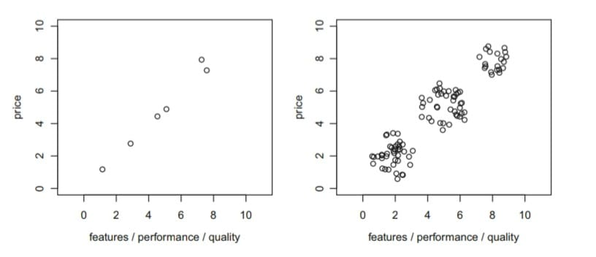

Simulation studies have shown that sample size has a significant effect on the correctness of segment recovery, as measured by the adjusted Rand index, which assesses the congruence between two segmentation solutions. Overall, market segmentation analysis requires careful consideration of sample size to ensure the accuracy and validity of the results.

Extracting Segments

The article discusses the exploratory nature of data-driven market segmentation analysis, which is often based on unstructured consumer data. The choice of segmentation method strongly affects the resulting segmentation solution, as algorithms impose structure on the extracted segments. Cluster analysis is a common method used, and selecting a suitable clustering method requires matching the data analytic features with context-dependent requirements. The article provides an illustrative example of how different algorithms impose structure on the extracted segments, using k-means cluster analysis and a dataset containing two spiralling segments.

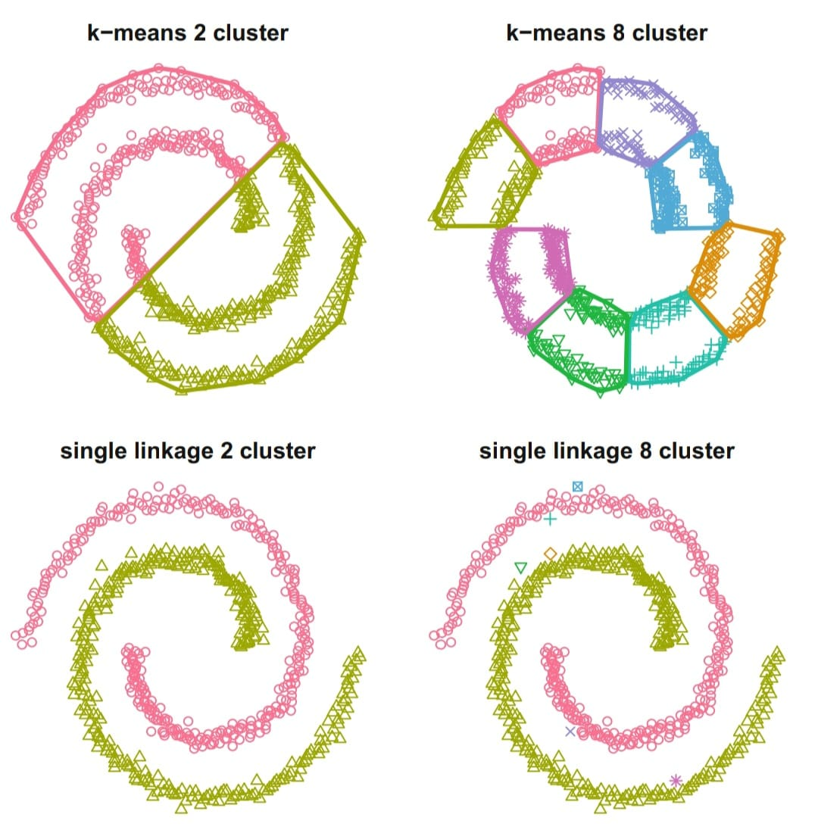

The article continues to discuss the example in Fig. 7.1, comparing the segmentation solutions obtained from k-means and single linkage hierarchical clustering algorithms. Single linkage correctly identifies the two spiralling segments in the data, while k-means fails to do so because it is designed to construct compact, round clusters. However, the article notes that there is no single best algorithm for all data sets, and the choice of algorithm depends on the structure and separation of the data. If data is not well-structured, the tendency of the algorithm will strongly influence the segmentation solution.

This chapter provides an overview of the most popular methods used in market segmentation, including distance-based and model-based methods. There is no single best algorithm for all situations, and each method has advantages and disadvantages. It is important to investigate and compare alternative segmentation solutions to arrive at a good final solution, considering data characteristics and expected or desired segment characteristics. Table 7.1 provides information to guide algorithm selection, such as the size of the available data set, the expected number and size of segments, and the scale level of the segmentation variables. Other special structures of the data can also restrict the set of suitable algorithms.

Distance Measures

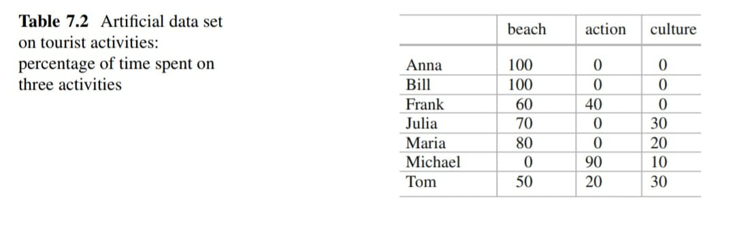

The given text explains the concept of measuring the distance between two vectors (representing observations) in market segmentation analysis. The distance is a function with two arguments - two vectors x and y - and the result is the distance between them. The text explains three common distance measures used in market segmentation analysis: Euclidean distance, Manhattan or absolute distance, and asymmetric binary distance. Euclidean distance measures the direct straight-line distance between two points in two-dimensional space, while Manhattan distance gives the distance assuming streets on a grid (like in Manhattan) need to be used to get from one point to another. Both Euclidean and Manhattan distances use all dimensions of the vectors x and y. The text also mentions the criteria that a distance measure must comply with, such as symmetry, the distance of a vector to itself being 0, and the triangle inequality.

d(x, y)=d(y, x) Symmetric Criteria

d(x, y)=0

Therefore, x=y

In addition, most distance measures fulfil the so-called triangle inequality:

D(x, z) < d(x, y) + d(y, z)

The triangle inequality says that if one goes from x to z with an intermediate stop in y, the combined distance is at least as long as going from x to z directly.

Hierarchical Methods

Hierarchical clustering methods are commonly used to group data in market segmentation analysis. These methods involve grouping observations or consumers into clusters, starting from either the complete data set or with each observation representing its own cluster. The process continues by either splitting or merging clusters until the complete data set forms one large market segment or until each observation represents its own market segment.

Agglomerative hierarchical clustering and divisive hierarchical clustering are two approaches used to group data. In agglomerative hierarchical clustering, each observation initially represents its own cluster, and then the two closest clusters are merged. This process continues until all the clusters form one large segment. Conversely, in divisive hierarchical clustering, the complete data set starts as one big market segment, which is split into two market segments in the first step. The two segments are then split into two new segments, and this process continues until each consumer has its own segment.

Single linkage: distance between the two closest observations of the two sets.

l(X, Y) = min x∈X, y∈Y d(x, y)

Complete linkage: distance between the two observations of the two sets that are farthest away from each other.

l(X, Y) = max x∈X, y∈Y d(x, y)

Average linkage: mean distance between observations of the two sets.

l(X, Y) = 1/|X||Y|∑ x∈X, ∑y∈Y d(x, y).

The different approaches result in a sequence of nested partitions ranging from partitions containing only one group to n groups. In general, hierarchical clustering is an exploratory technique used to reveal different features of the data. Different combinations of distance measures and linkage methods can be used in clustering to reveal different features of the data.

Several linkage methods are available, including single linkage, complete linkage, and average linkage. Single linkage uses a “next neighbor” approach to join sets, meaning that the two closest consumers are united. This method is useful for revealing non-convex, non-linear structures in data. Complete and average linkage are better at extracting more compact clusters.

Another popular clustering method is Ward clustering, which is based on squared Euclidean distances. It involves joining sets of observations based on the minimal weighted squared Euclidean distance between cluster centers. The resulting clusters' midpoints are the segment representatives. The hierarchical clustering method's output is presented as a dendogram, which is a tree diagram representing the hierarchy of market segments formed at each step of the procedure.

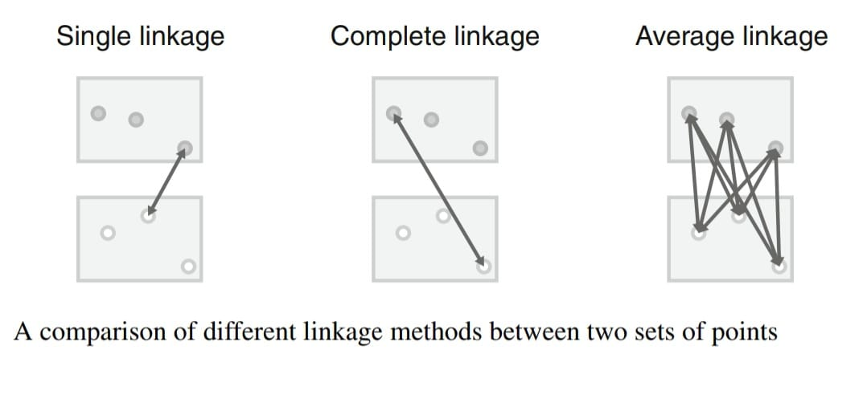

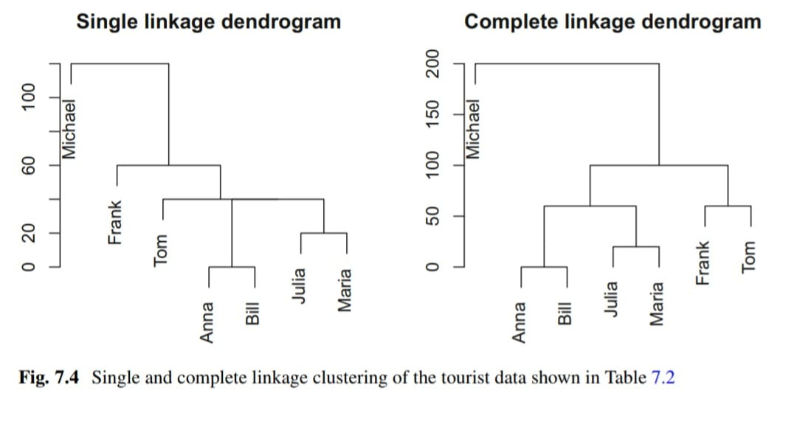

Partitioning Methods

Hierarchical clustering is effective for small data sets with up to a few hundred observations, but becomes impractical for larger data sets due to the difficulty of reading dendrograms and the memory requirements for pairwise distance matrices. For larger data sets, clustering methods that create a single partition are more suitable, as they only need to calculate distances between each observation and the centers of segments. Partitioning clustering algorithms can extract a specific number of segments with fewer distance calculations than hierarchical clustering, making them more efficient for larger data sets. It is better to optimize specifically for the goal of extracting a few segments rather than building a complete dendogram and cutting it into segments heuristically.

K- Means and K-Centroid Clustering

The k-means clustering method is a popular partitioning method that divides a set of observations (consumers) into subsets (market segments) based on their similarity. The algorithm uses a representative value called the centroid, which is the column-wise mean of all members in the segment. The goal is to group consumers into a given number of segments so that they are similar to their fellow segment members, but dissimilar to members of other segments. The algorithm is iterative, improving the partition in each step and bound to converge, but not necessarily to the global optimum. R function kmeans() implements different algorithms for k-means clustering using the squared Euclidean distance, and flexclust provides a generalization to other distance measures.

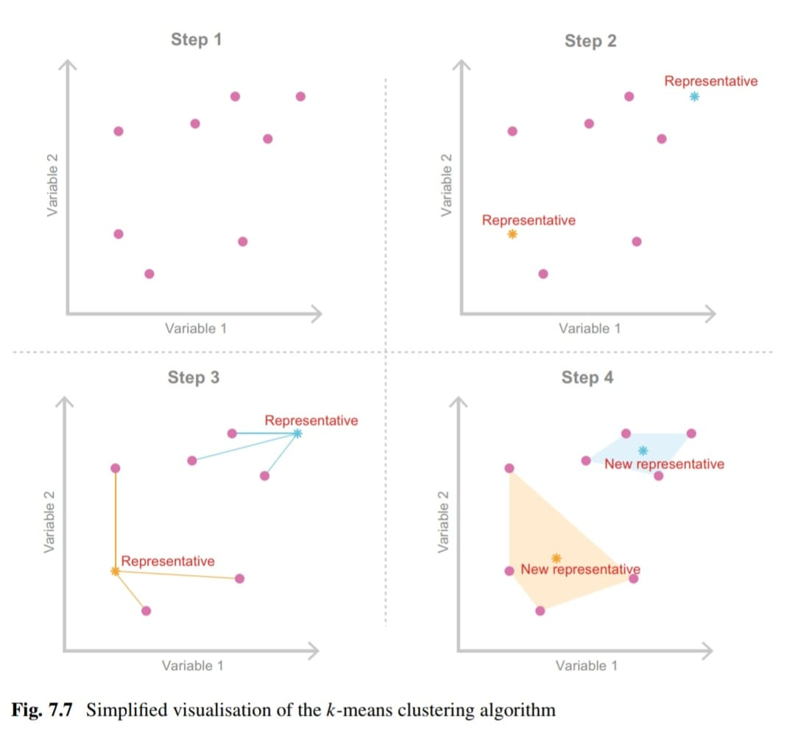

“Improved” K-Means

To improve the k-means clustering algorithm, it is recommended to use "smart" starting values instead of randomly drawing k consumers from the data set. Randomly drawn consumers may not be representative of the data space and can increase the likelihood of the algorithm getting stuck in a local optimum. One way to avoid this is to initialise the algorithm using starting points that are evenly spread across the entire data space. Steinley and Brusco (2007) compared 12 different strategies for initialising the k-means algorithm and found that the best approach is to randomly draw many starting points and select the best set based on their ability to represent the data. Good representatives are those that are close to their segment members, while bad representatives are far away from their segment members.

Hard Competitive Learning

Hard competitive learning, also known as learning vector quantization, is an algorithm for market segmentation that is different from the standard k-means algorithm in how segments are extracted. It randomly selects one consumer and moves their closest segment representative a small step in the direction of the randomly chosen consumer, rather than using all consumers in the data set to determine new segment representatives at each iteration. This procedural difference can lead to different segmentation solutions and hard competitive learning may find the globally optimal market segmentation solution while k-means gets stuck in a local optimum. An application of hard competitive learning in market segmentation analysis can be found in Boztug and Reutterer (2008), where it is used for segment-specific market basket analysis. Hard competitive learning can be computed in R using the function cclust(x, k, method = "hardcl") from package flexclust.

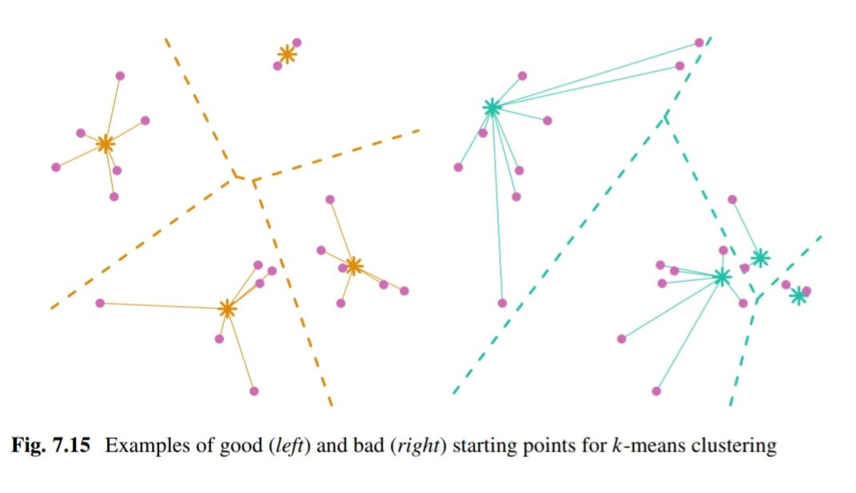

Neural Networks

Auto-encoding neural networks are a family of algorithms for cluster analysis that use a single hidden layer perceptron as the most popular method. The network has three layers: input, hidden, and output. The input layer takes the data as input, the output layer gives the response of the network, and the hidden layer has no connections to the outside of the network. The values of the nodes in the hidden layer are weighted linear combinations of the inputs for a non-linear function, and the outputs are weighted combinations of the hidden nodes. The method is mathematically different from all cluster methods presented so far, and it has been used in a marketing context by Natter (1999). Hruschka and Natter (1999) compare neural networks and k-means.

hj = fj (∑i=1 to 5 αijxi)

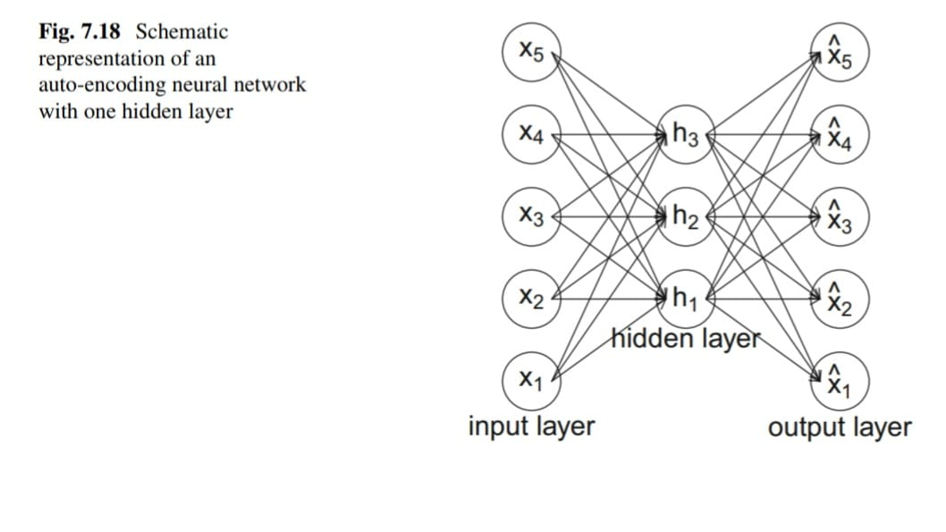

Hybrid Approaches

Hybrid segmentation approaches combine hierarchical and partitioning algorithms to compensate for their weaknesses. Hierarchical clustering algorithms allow for an unspecified number of market segments and visualisation, but require substantial memory capacity. Partitioning clustering algorithms have minimal memory requirements but require a specified number of segments and do not allow for tracking changes in segment membership. Hybrid approaches use partitioning algorithms to extract a larger number of segments initially, then retain only the segment centers and sizes for input into hierarchical clustering. This reduces the data set size and enables decision-making on the number of segments to extract.

Two-step Clustering

The two-step clustering procedure, implemented in IBM SPSS, involves a partitioning step followed by a hierarchical step. In the first step, k-means is used to extract a large number of clusters, from which representative members are retained to reduce the data set size. In the second step, hierarchical clustering is applied to the representatives to extract the desired number of segments. The original data is then linked to the segmentation solution using function twoStep() from package MSA. This procedure has been used in various application areas, and can be demonstrated using R commands on an artificial mobile phone data set. The resulting plot shows the correct segmentation solution extracted from the data.

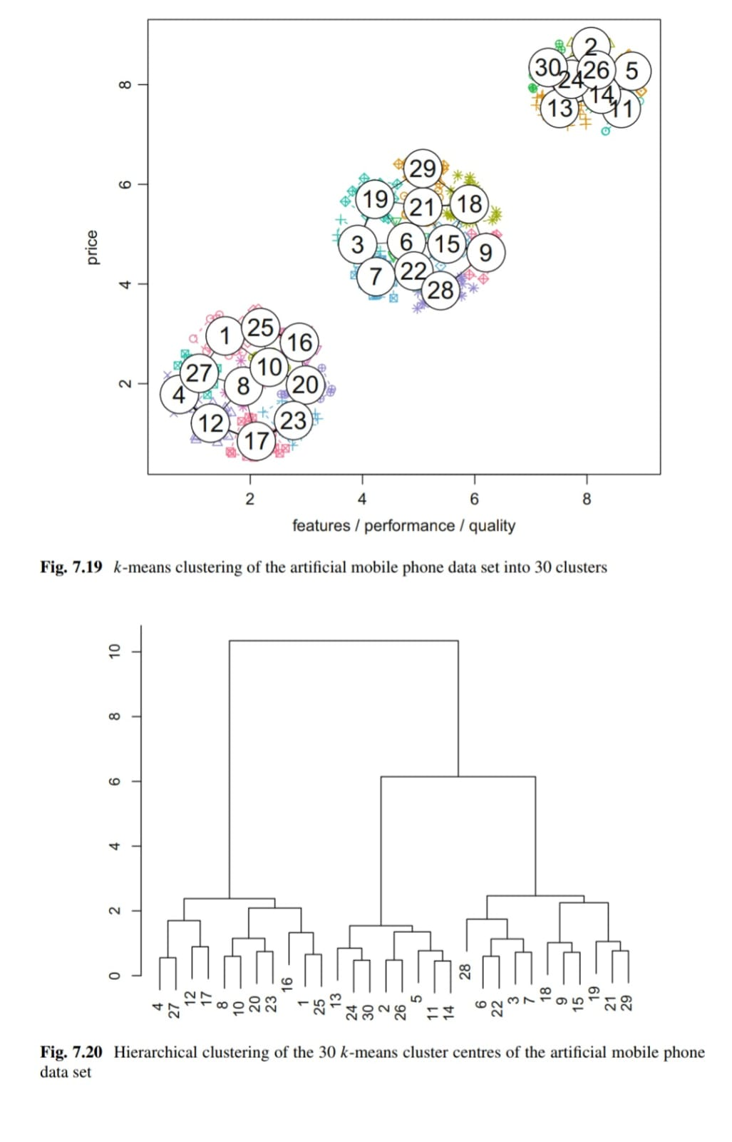

Bagged Clustering

Bagged clustering is a segmentation method that combines partitioning and hierarchical clustering algorithms with bootstrapping to identify market segments. The method involves creating multiple bootstrap samples from the original data set and then performing repeated partitioning clustering analyses to generate cluster centroids. These centroids are used to create a derived data set that is then subjected to hierarchical clustering analysis, resulting in a dendrogram that can provide clues about the number of market segments to extract. The final segmentation solution is determined by selecting a cut point for the dendogram and assigning each original observation to the closest market segment. The method has been successfully applied to tourism data, including a data set containing responses from 2961 tourists surveyed as part of the Austrian National Guest Survey in winter 1997/1998. The data set contains 27 binary segmentation variables related to winter vacation activities, and the marketing challenge is to identify tourist market segments based on these activities.

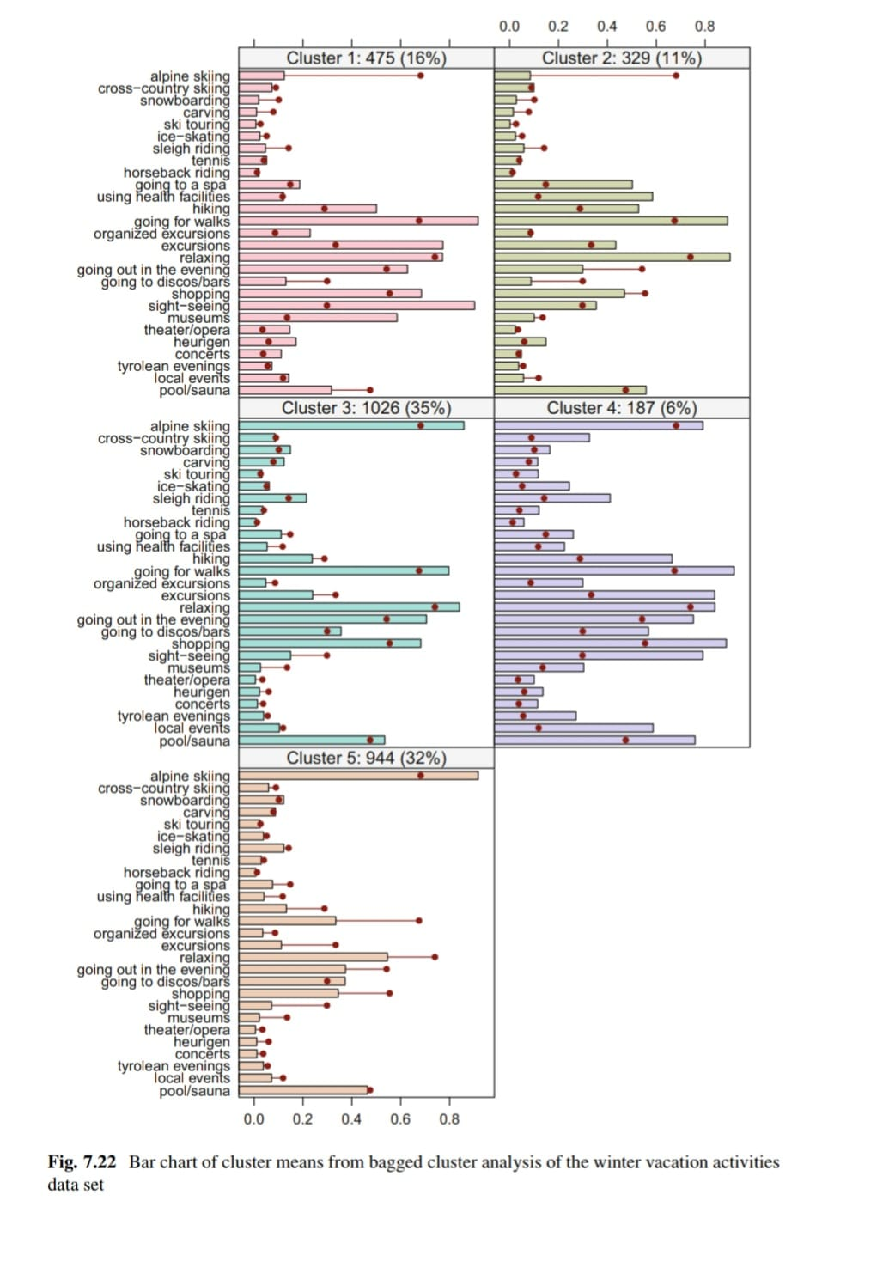

Model Based Methods

The article discusses the use of model-based methods as an alternative to distance-based methods in market segmentation analysis. The authors argue that using a range of extraction methods is helpful in determining the most suitable approach for the data at hand. Model-based methods do not rely on similarities or distances but instead assume that each market segment has a certain size and specific characteristics. These properties are not known in advance but are determined empirically using the data. The authors suggest that model-based methods offer a genuinely alternative extraction technique and may prove to be influential in marketing research.

Normal Distribution

The article discusses the use of a mixture of multivariate normal distributions as a popular finite mixture model for market segmentation analysis when dealing with metric data. This model is useful in cases where variables are correlated, and the multivariate normal distribution can model covariance between variables. The model has two sets of parameters: mean and variance. For each segment, there is a segment-specific mean vector and covariance matrix that contains the variances and covariances between the segmentation variables. The segment-specific parameters are the combination of the mean vector and covariance matrix, resulting in a total number of parameters to estimate of p + p(p + 1)/2.

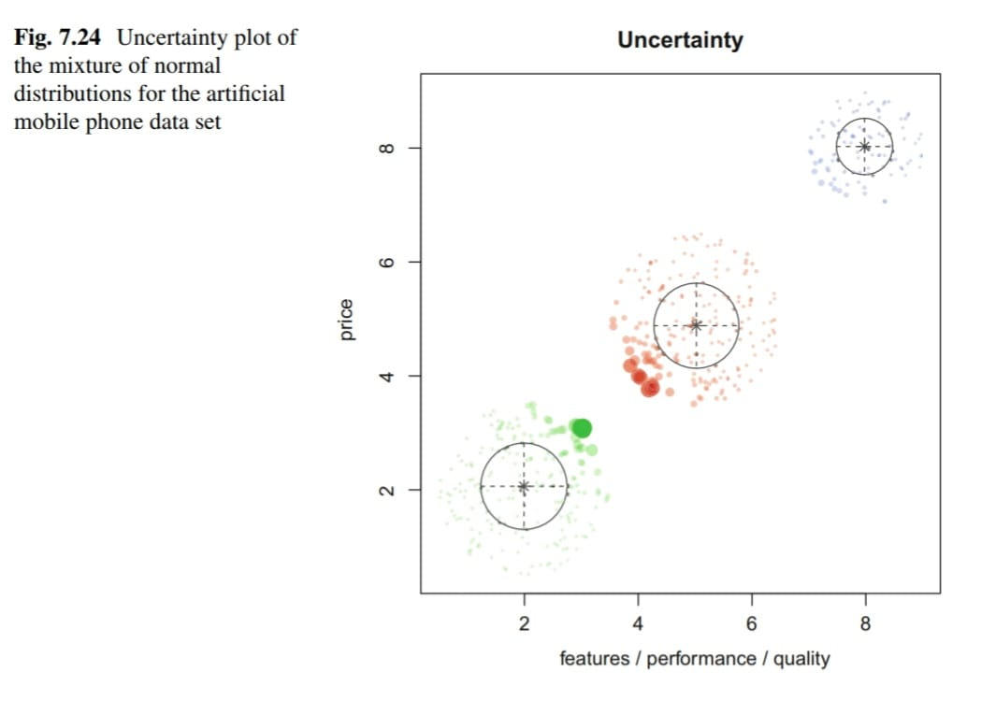

Binary Distribution

Finite mixtures of binary distributions, also known as latent class models or latent class analysis, are used for binary data where the segmentation variables are binary (0 or 1). This model assumes that different groups of respondents have different probabilities of undertaking certain activities, leading to negative correlation between certain variables in the overall data set. For example, some respondents may be interested in alpine skiing but not in sight-seeing, while others may be interested in sight-seeing but not in skiing. The mixture model allows us to identify these groups of respondents and their preferences.

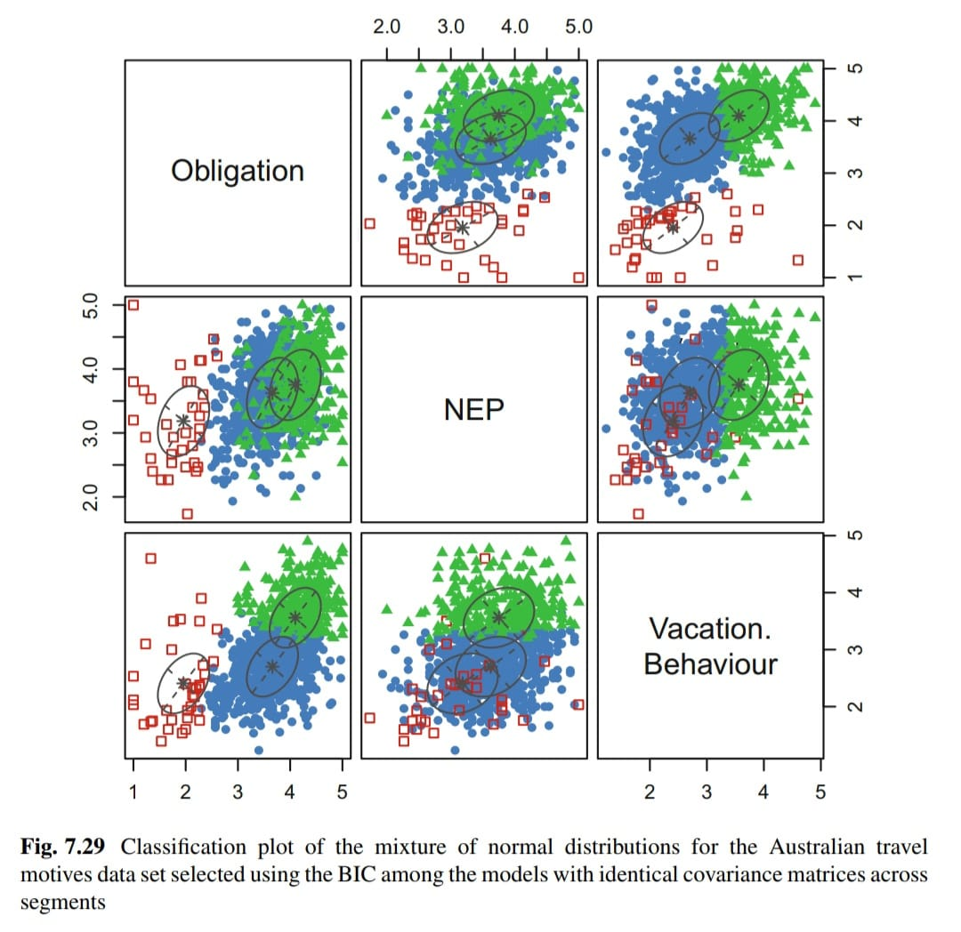

Algorithms with Integrated Variable Selection

Biclustering Algorithms

Biclustering is a technique that simultaneously clusters both consumers and variables to identify groups of consumers who share common characteristics for a subset of variables. This approach is particularly useful for binary data such as genetic and proteomic data where traditional clustering algorithms are not effective due to the large number of variables and noisy data. Biclustering has experienced a big revival in recent years, and several popular biclustering algorithms exist with different ways of defining a bicluster. The goal of biclustering is to identify large groups of consumers who have as many variables in common as possible.

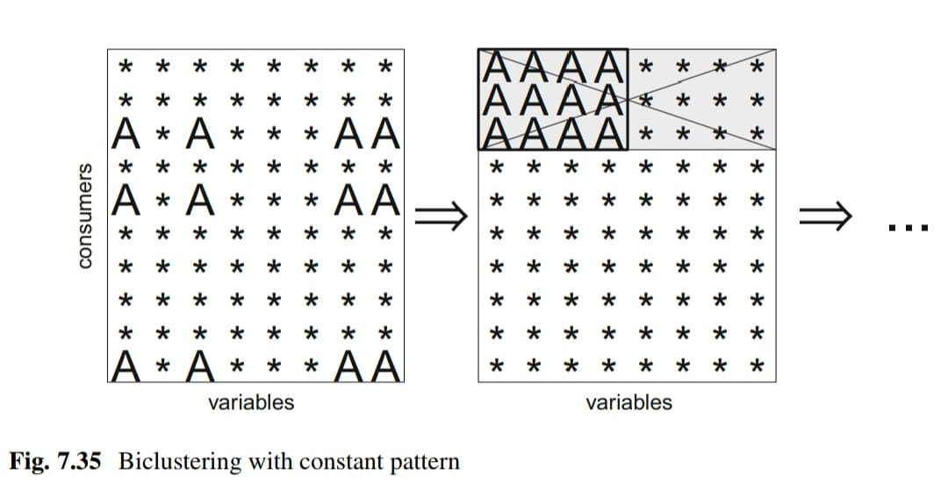

Variable Selection Procedure for Clustering Binary Data (VSBD)

Brusco (2004) proposed the VSBD method for clustering binary datasets, based on the k-means algorithm. The method identifies the best small subset of variables for clustering, using the within-cluster sum-of-squares criterion. It then adds additional variables one by one, selecting the one leading to the smallest increase in the within-cluster sum-of-squares criterion, until a threshold is reached. The number of segments k has to be specified in advance, and can be selected using the Ratkowsky and Lance index. Brusco recommends a large number of random initialisations for the k-means algorithm, but using the more efficient Hartigan-Wong algorithm allows for fewer initialisations.

The algorithm works as follows:

Step 1: Select only a subset of observations with size φ ∈ (0, 1] times the size of the original data set. Brusco (2004) suggests to use φ = 1 if the original data set contains less than 500 observations, 0.2 ≤ φ ≤ 0.3 if the number of observations is between 500 and 2000 and φ = 0.1 if the number of observations is at least 2000.

Step 2: For a given number of variables V, perform an exhaustive search for the set of V variables that leads to the smallest within-cluster sum-of-squares criterion. The value for V needs to be selected small for the exhaustive search to be computationally feasible. Brusco (2004) suggests using V = 4, but smaller or larger values may be required depending on the number of clusters k, and the number of variables p. The higher the number of clusters, the larger V should be to capture the more complex clustering structure. The higher p, the smaller V needs to be to make the exhaustive search computationally feasible.

Step 3: Among the remaining variables, determine the variable leading to the smallest increase in the within-cluster sum-of-squares value if added to the set of segmentation variables.

Step 4: Add this variable if the increase in within-cluster sum-of-squares is smaller than the threshold. The threshold is δ times the number of observations in the subset divided by 4. δ needs to be in [0, 1]. Brusco (2004) suggests a default δ value of 0.5.

Variable Reduction: Factor-Cluster Analysis

The article discusses the use of factor-cluster analysis in market segmentation, which involves factor analyzing segmentation variables and using the resulting factor scores to extract market segments. The approach may be conceptually legitimate in cases where the data comes from validated psychological test batteries, but it is more commonly used when the number of segmentation variables is too high relative to the sample size. The article suggests that a sample size of at least 100 times the number of segmentation variables is needed for reliable results, but many studies use fewer variables and smaller sample sizes.

Data Structure Analysis

Cluster Indices

o make critical decisions in market segmentation analysis, data analysts need guidance, and cluster indices provide such guidance. Two types of cluster indices exist, namely internal and external cluster indices. Internal cluster indices use information contained in a single segmentation solution, while external cluster indices require another segmentation as additional input. The most commonly used measures of similarity of two market segmentation solutions are the Jaccard index, the Rand index and the adjusted Rand index. The former measures the similarity between two sets of segment memberships, while the latter two measure the agreement between two sets of segmentations.

Internal Cluster Indices

Internal cluster indices are used to evaluate the compactness and separability of market segments in a single segmentation solution. They require a distance measure between observations, a segment representative or centroid, and a representative for the complete data set. One common internal cluster index is the sum of within-cluster distances, which measures the compactness of clusters. The scree plot is a commonly used graph to select the number of market segments based on this index, and an elbow in the plot indicates a good segmentation solution. However, consumer data may not always have a distinct elbow in the scree plot, making it challenging to determine the optimal number of segments. Another variation of this index is the Ball-Hall index, which divides the sum of within-cluster distances by the number of segments to correct for the monotonous decrease of the internal cluster index with increasing numbers of segments.

Wk = ∑h=1 to k ∑x∈Sh d(x, ch)

External Cluster Indices

The passage discusses the evaluation of market segmentation solutions using external cluster indices, which require additional information beyond the original data. While the true segment structure is rarely known for consumer data, a repeated calculation using different clustering algorithms or variations of the original data can serve as external information. However, a problem with comparing segmentation solutions is label switching, where the labels of the segments are arbitrary and can vary between solutions. To address this, the focus should be on whether pairs of consumers are assigned to the same segments repeatedly, rather than on the individual segment labels. The passage outlines the four possible outcomes when comparing two market segmentation solutions for any two consumers.

• a: Both consumers are assigned to the same segment twice.

• b: The two consumers are in the same segment in P1, but not in P2.

• c: The two consumers are in the same segment in P2, but not in P1.

• d: The two consumers are assigned to different market segments twice.

Global Stability Analysis

Resampling methods can provide insight into the stability of market segmentation solutions across repeated calculations. To assess the global stability of a segmentation solution, several new data sets are generated using resampling methods, and a number of segmentation solutions are extracted. The stability of the segmentation solutions across repeated calculations is compared, and the solution that can best be replicated is chosen. Resampling methods can be valuable in market segmentation analysis because consumer data rarely contain distinct, well-separated market segments. There are three possible scenarios for consumer data: natural segments exist, data is entirely unstructured, or data lacks distinct, well-separated natural clusters. Global stability analysis helps determine which scenario applies to any given data set. The problem of sample randomness can be addressed by dividing the sample of respondents into subsamples and extracting market segments independently for each of the subsamples.

Segment Level Stability Analysis

Segment Level Stability Within Solutions(SLSW)

The concept of segment level stability within solutions (SLSW) proposed by Dolnicar and Leisch (2017) assesses the stability of individual segments in a market segmentation solution, rather than the entire solution as a whole. This approach allows for the detection of highly stable segments, such as potential niche markets, even in solutions where other segments may be unstable. SLSW is calculated by repeatedly drawing bootstrap samples and calculating segmentation solutions independently for each sample, then determining the maximum agreement across all calculations using a method proposed by Hennig (2007). The authors demonstrate the procedure using an artificial mobile phone dataset and find that if the correct number of segments (three) are extracted, SLSW is high, but if more than three segments are extracted, some segments may have low SLSW due to splitting up of a larger natural segment. The SLSW approach is useful for organizations that only need to target one suitable market segment for survival and competitive advantage.

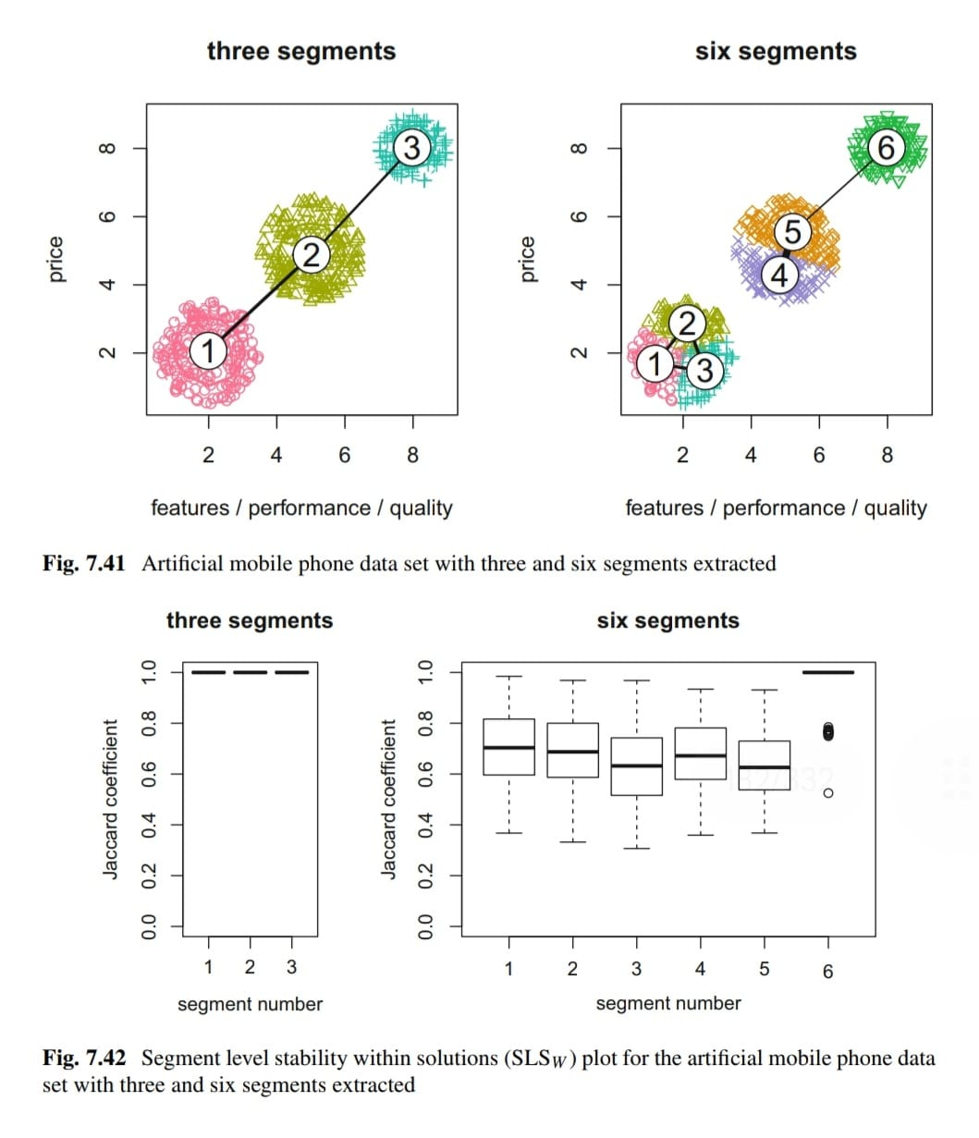

Segment Level Stability Across Solutions (SLS4)

The segment level stability across solutions (SLSA) criterion is used to evaluate the stability of market segments across different segmentation solutions. High values of SLSA indicate natural segments that exist in the data, while low values suggest artificial segments created during the segmentation process. To calculate SLSA, a series of partitions with different numbers of segments are analyzed, and the similarity between segments in neighboring partitions is identified by relabeling the segments. The SLSA plot shows the development of each segment across different segmentation solutions, and thick lines indicate stubborn market segments that re-occur across solutions, while branching lines suggest changing segment membership and the possibility of artificially created segments. The SLSA criterion helps data analysts identify natural segments in the data, which are more attractive to organizations as they do not require managerial judgement for their creation.

